**FACIAL EXPRESSION DETECTION USING GABOR FILTER**

**Software Requirement Specification**

**Version 1.0**



**Swami Keshvanand Institute Of Technology, Management & Gramothan, Jaipur, Rajasthan**

**Project Mentor: Team Members:**

Mrs. Neha Janu (Reader CS/IT) Rajat Gupta (12ESKCS091)

Subroto Biswas (12ESKCS)

**Submitted To:**

Prashant Kathuria (12ESKCS)

Mrs. Priyanka Sharma (Lecturer CS/IT)

Tushar Mittal (12ESKCS120)

**Department of Computer Science & Engineering**

**Rajasthan Technical University**

1

|  |  |
| --- | --- |
| Smart CheckList(SCL) | Version-1.0 |
| Software Requirements Specification | Date:15-Aug-2015 |
| SR |  |

**Table Of contents**

01. Introduction 4

1.1 Purpose 4

1.2 Problem Description 4

1.3 Objectives 5

1.3 Definitions, Acronyms and Abbreviations 5

1.4 Overview 5

02. Overall Description 6

2.1 Product Perspective 6

2.2 Overview of Functional Requirements 7

2.3 Overview of Data Requirements 7

2.3.1 Input 7

2.3.2 Output 7

2.3.3 Internal Data 8

2.4 General Constraints, Assumptions, Dependencies, Guidelines 8

2.4.1 Software Constraints 8

2.4.2 Hardware Constraints 8

2.4.3 Guidelines 8

2.4.4 Assumptions 8

03. Specific Requirements 9

3.1 Functional Requirements 9

3.1.1 Enrollment 9

3.1.2 Verification 9

3.1.3 Identification 10

3.3 Reliability 10

3.4 Performance 11

3.5 Application 11

2

|  |  |
| --- | --- |
| Smart CheckList(SCL) | Version-1.0 |
| Software Requirements Specification | Date:15-Aug-2015 |
| SR |  |

**List of Figures**

Figure 1- High level system description diagram 6

Figure 2- Internal functions of the product 7

Figure 3- Project work flow 7

Figure 4- Functions of the biometric system 10

Figure 5- Use case Diagram 12

3

|  |  |
| --- | --- |
| Smart CheckList(SCL) | Version-1.0 |
| Software Requirements Specification | Date:15-Aug-2015 |
| SR |  |

**01. Introduction**

**1.1 Purpose**

This document describes the functional, non-functional and hardware requirements and the importance of a Facial Expression recognition system with briefly presenting its input and output functionalities. And also this would give an overview to the client and would give detail specification for the developer.

**1.2 Problem Description**

Personal identification system based on the images of the face is often effective due to its user friendly nature. But there are many more facts like race, age, gender and facial coverings that affects when identifying persons using the existing facial expression recognition systems. And the output may also change due to the differences of the image quality and the amount of back ground clutter. During the past few years facial expression recognition received increased attention and has advanced technically. But significant research efforts still have been focused on this area. Though many facial expression recognitions systems have been proposed and have demonstrated significant promises, robust facial expression recognition is still under research.

In a high volume, high speed environments, facial expression recognition systems do not have the accuracy, reliability or ability to handle large, diverse population as needed for critical applications and up to now it is challengeable.

4

|  |  |
| --- | --- |
| Smart CheckList(SCL) | Version-1.0 |
| Software Requirements Specification | Date:15-Aug-2015 |
| SR |  |

**1.3 Objectives**

This project is aimed at,

* + Detecting facial expressions of images on a given dataset by applying Gabor filter and them and finding a feature matrix.
  + Optimizing already developed algorithms for facial expression detection by altering different Gabor parameter values.

**1.3 Definitions, Acronyms and Abbreviations**

|  |  |
| --- | --- |
| **Acronyms** | **Description** |
|  |  |
| API | Application Programming Interface |
|  |  |
| GUI | Graphical User Interface |
|  |  |

**1.4 Overview**

Section 2 here deals with the overall description about the product while describing the product perspective, functional and data requirements, input and output data, general constraints and assumptions of the application briefly. Section 3 gives the detailed description about the functional and non-functional requirements of the application.

5

|  |  |
| --- | --- |
| Smart CheckList(SCL) | Version-1.0 |
| Software Requirements Specification | Date:15-Aug-2015 |
| SR |  |

**02. Overall Description**

**2.1 Product Perspective**

This product is aimed to provide a best fitted engine to enroll, verify and identify face expression data at a high speed and very low error rate. As the input devices, web cam, scanner or any other image acquisition device can be used where user feeds input through this image acquisition device while processed biometric information is stored in an internal dataset. Product will do the comparison between internal dataset and given inputs by the user at identification.

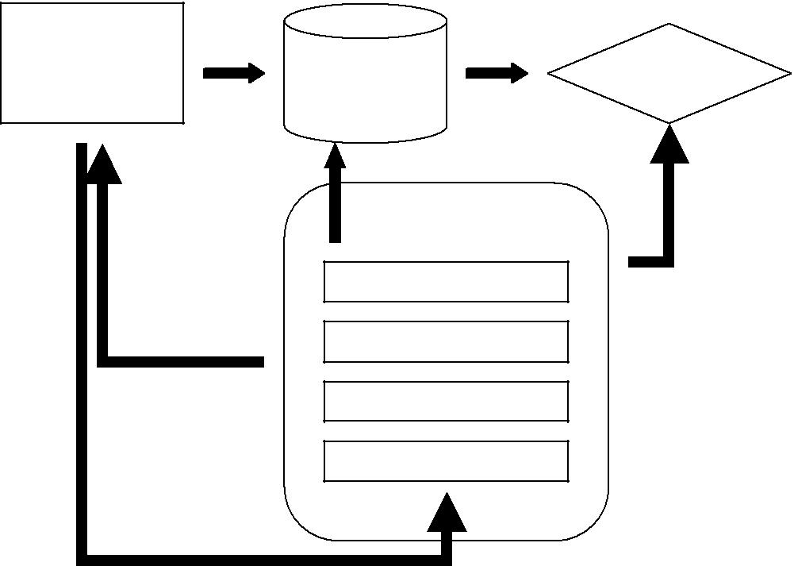

|  |  |  |  |  |
| --- | --- | --- | --- | --- |
| **Image** | **Enrolment** |  | **Decision** |  |
| **Acquisition** | **Matching** |  |
| **Device** | **Database** |  | **Making** |  |
|  | **Signal Processing** |  |  |  |
|  | Template Creation |  | Verification & |  |
| Re-acquire | Quality Control |  | Identification |  |
|  |  | Outcome |  |
|  |  |  |  |
|  | Feature Extraction |  |  |  |
|  | Segmentation |  |  |  |
| Samples |  |  |  |  |
|  | **Figure 1- High level system description diagram** | |  |  |

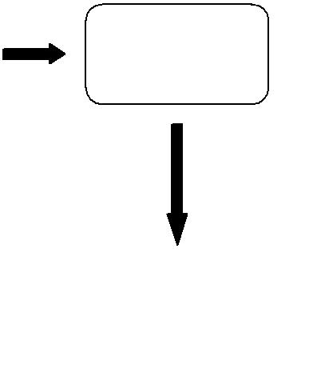

6

|  |  |
| --- | --- |
| Smart CheckList(SCL) | Version-1.0 |
| Software Requirements Specification | Date:15-Aug-2015 |
| SR |  |

**2.2 Overview of Functional Requirements**

This is a research project on structural facial expression recognition algorithms on large Datasets.

Our application is capable of *enrolling facial images*, verifying and identifying those images. System should be provided with the face images of different expressions captured through an image acquisition device. The distinctive measures of the enrolling images are extracted and stored in the dataset as a “template” called feature matrix. When it is used to match information, the specific template will be compared to many templates or all templates already in the dataset and determine if there is a match.

The research is done for more accurate high speed algorithms for image matching on large dataset.

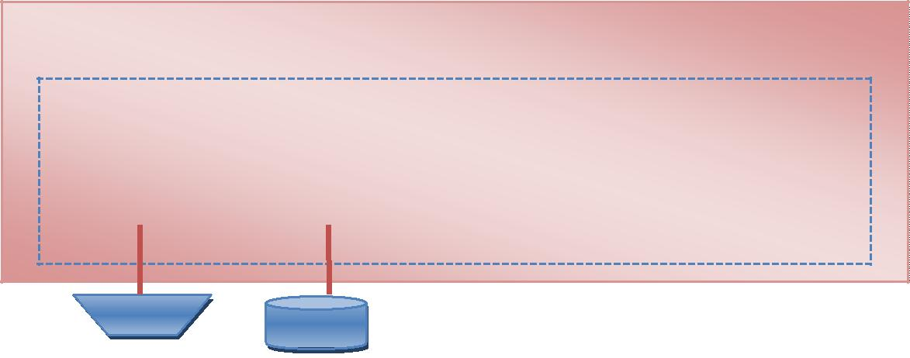

**Internal Functions**



|  |  |  |  |  |  |  |
| --- | --- | --- | --- | --- | --- | --- |
| Sensor  Function |  | Archive  Function |  | Processing  Algorithm  Function |  | Matching  Algorithm  Function |

**Figure 2- Internal functions of the product**

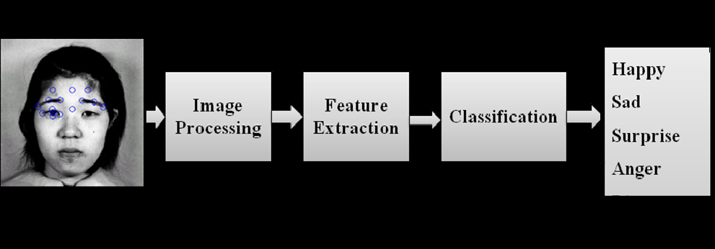

**Figure 3- Project Work Flow**

7

|  |  |
| --- | --- |
| Smart CheckList(SCL) | Version-1.0 |
| Software Requirements Specification | Date:15-Aug-2015 |
| SR |  |

**2.3 Overview of Data Requirements**

**2.3.1 Input**

Inputs are the facial images of the person, in the purpose of identification.

**2.3.2 Output**

Database records with the personal details of the matched image against the given image, or system generated alerts on strange data patterns.

**2.3.3 Internal Data**

The program maintain following internal data

* + Biometric Template (the feature matrix) that consists with the measured features of the images.

1. **General Constraints, Assumptions, Dependencies, Guidelines**
2. **Software Constraints** 
   * Windows 2000, Windows XP or Linux as the operating system.
   * MATLAB version 2015 as image processing tool.
3. **Hardware Constraints** 
   * Camera or any other image acquisition device.
   * Minimum of 1GB RAM
4. **Guidelines** 
   * Code is kept clean and simple for future upgrades and maintenance
5. **Assumptions** 
   * + User will provide front view of the face image with a preferable quality.

8

|  |  |
| --- | --- |
| Smart CheckList(SCL) | Version-1.0 |
| Software Requirements Specification | Date:15-Aug-2015 |
| SR |  |

**03. Specific Requirements**

**3.1 Functional Requirements**

The main purpose of this project is to provide a best fitted engine for facial expression recognition. The following functions are provided through an API.

**3.1.1 Enrollment**

In enrolment, samples of facial images are captured from the sensor unit and processed them in to a usable form and stored in the dataset for that individual. And it involves

* + Sample acquisition
  + Segmentation and feature extraction
  + Quality checks
  + Template creation (converts the captured images in to usable format and stored in the database)

**3.1.2 Verification**

In verification, one or more samples of facial images are captured, processed into a usable form, and then matched against a reference template to check whether essential features are there. The image will match highest probability with the reference images.

It involves

* + - Comparison of the sample features against the reference template
    - A verification decision based on the match result with the reference template

9

|  |  |
| --- | --- |
| Smart CheckList(SCL) | Version-1.0 |
| Software Requirements Specification | Date:15-Aug-2015 |
| SR |  |

**3.1.3 Identification**

In identification, facial image of a person is captured, processed into a usable form (template), and matched against a set of templates stored in the dataset. The final result may be empty or contain only one identifier that is best fitted to the captured image. System should be capable of identifying the facial expression among the dataset with a reasonable speed. That would be the final goal of the research.

Identification involves

* Sample acquisition;
* Segmentation and feature extraction;
* Quality checks
* Comparison against templates stored in the database
* An identification decision based matching result in one or more attempts

|  |  |  |  |  |  |  |  |  |  |  |  |  |  |  |  |  |  |  |  |  |
| --- | --- | --- | --- | --- | --- | --- | --- | --- | --- | --- | --- | --- | --- | --- | --- | --- | --- | --- | --- | --- |
|  |  | |  |  |  |  |  |  |  | Image data or | | |  |  |  |  |  |  |  |  |
|  |  | |  | Sensor data | | | |  |  |  |  | Feature data | | | |  |
|  |  | |  |  |  | Behavioral data | | | |  |  |  |
|  |  | |  | Acquired data | | | | |  |  |  | (Processed data) | | | |  |
|  |  | |  |  | (Intermediate data) | | | |  |  |  |
|  |  | |  |  |  |  |  |  |  |  |  |  |  |  |  |  |
|  |  | |  |  |  |  |  |  |  |  |  |  |  |  |  |  |  |  |  |  |
|  |  | |  |  |  |  |  |  |  |  |  |  |  |  |  |  |  |  |  |  |
|  |  | |  |  |  |  |  |  |  |  |  |  |  |  |  |  |  |  |  |  |
| **Sensor** |  | **Data** | | |  |  |  | **Data Pre-** | | |  |  | **Feature** | | |  |  |  |  |  |
|  |  | **Acquisition** | | |  |  |  | **Processing** | | |  |  | **Extraction** | | | |  |  |  |  |
|  |  | |  |  |  |  |  |  |  |  |  |  |  |  |  |  |  |  |  |  |

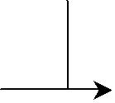

**Figure 4- Functions of the biometric system**

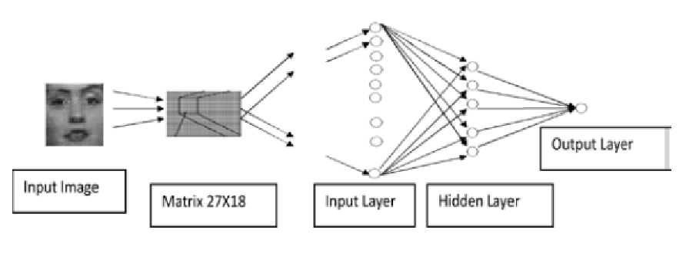

10

|  |  |
| --- | --- |
| Smart CheckList(SCL) | Version-1.0 |
| Software Requirements Specification | Date:15-Aug-2015 |
| SR |  |

**3.3 Reliability**

The system should perform reliable identification with large databases, as biometrical identification systems tend to accumulate False Acceptance Rate with database size increase.

**3.4 Performance**

The system should response user within few seconds since the facial expression recognition systems are real time. Therefore the engine we implement here should have low response time. So the facial expression recognition time should be low and it requires high computational power. On the other hand this system will maintain a large database which consists of all possible data. So the data processing time while identifying a particular image on the database should also be very low.

**3.5 Application**

A simple GUI application will be implemented for the demonstration purpose of the verification engine.

.

11

**Use Case Diagram**

Actors:

1. User
2. System

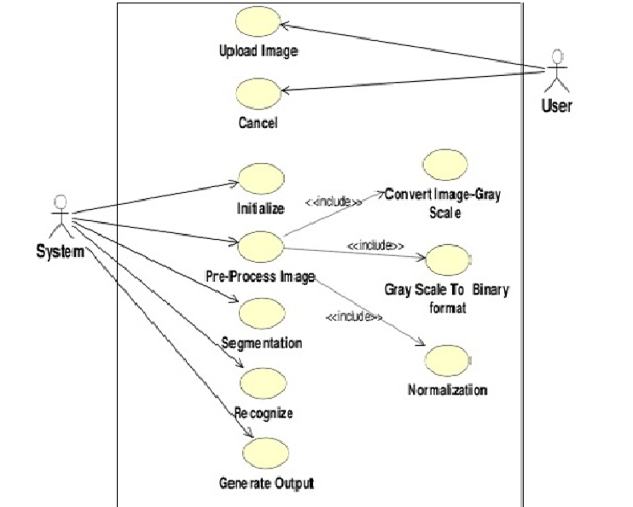

**Figure 5- Use Case Diagram**

12